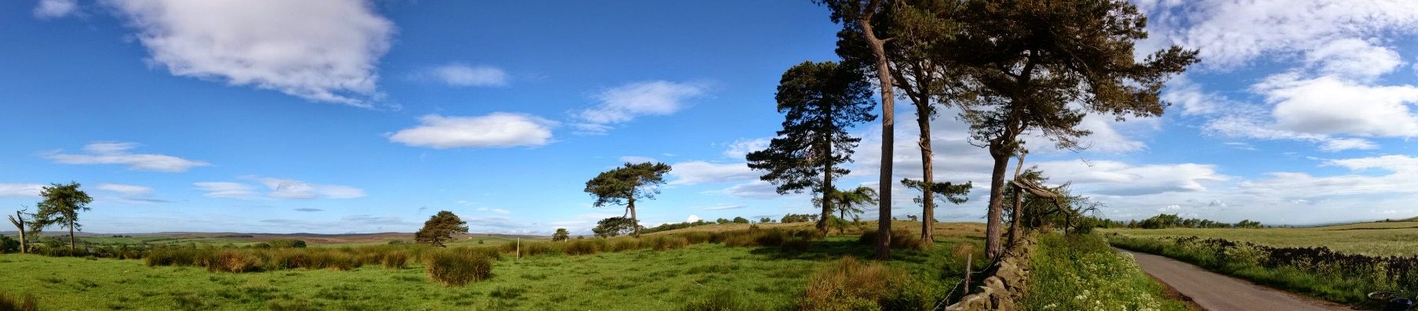
The highest point of the race – 265m, 6.6 km

The Grewelthorpe Multiterrain Race
OCTOBER

Race Information

Important times

0830 Registration opens
1030 Registration closes
1055 Race briefing (at start)
1100 Race starts
1330 Prize giving (at Village Hall)

Parking
Parking is available at Newholme Caravan Site at the south east side of the village, and down the lane behind the pub. Parking marshals will guide you to the parking areas and show you where to park. Please watch out for pedestrians while parking and traffic while walking to registration in the village hall.

Allow 5 minutes’ walk between car parks and registration and registration and the race start.

Toilets and Changing
Toilets are available in the Village Hall. These are a short walk (600m) from the start. There will be a portaloo in the start/finish field.

Registration
Registration opens at 0830 in the Village Hall
where you will pick up your race number and timing chip. Registration closes at 10h00 promptly.

Prizes
Cash prizes sponsored by I’Anson’s for 1st, 2nd, 3rd and age category prizes (1st only).
Prize for first local male and female. There is a bottle of wine prize for the first female/male team. Details at registration!

Top of the first climb – 238 m, 2.3 km
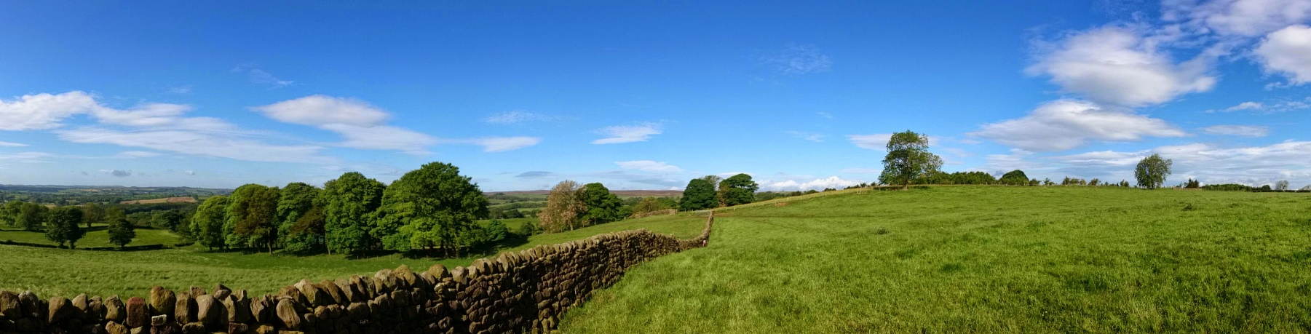
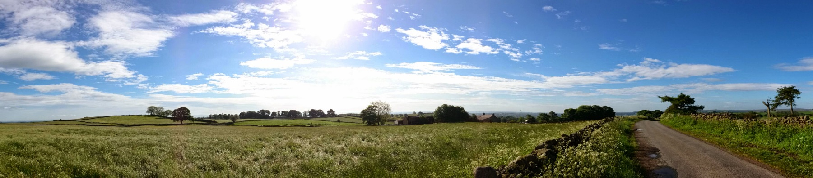
The highest point of the race – 265m, 6.6 km

Location

Start/Finish: SE 22713 76333 Nearest postcode HG4 3BZ
Village Hall: SE 23121 76130 Nearest postcode HG4 3BU
Parking (Caravan site): SE 23401 75790 Nearest postcode HG4 3DR
Parking (Pub): SE 23012 76285 Nearest postcode HG4 3BY

Water

Water will be available at 5.5km, 10km and at the Finish. Other refreshments will be available in the Village Hall.

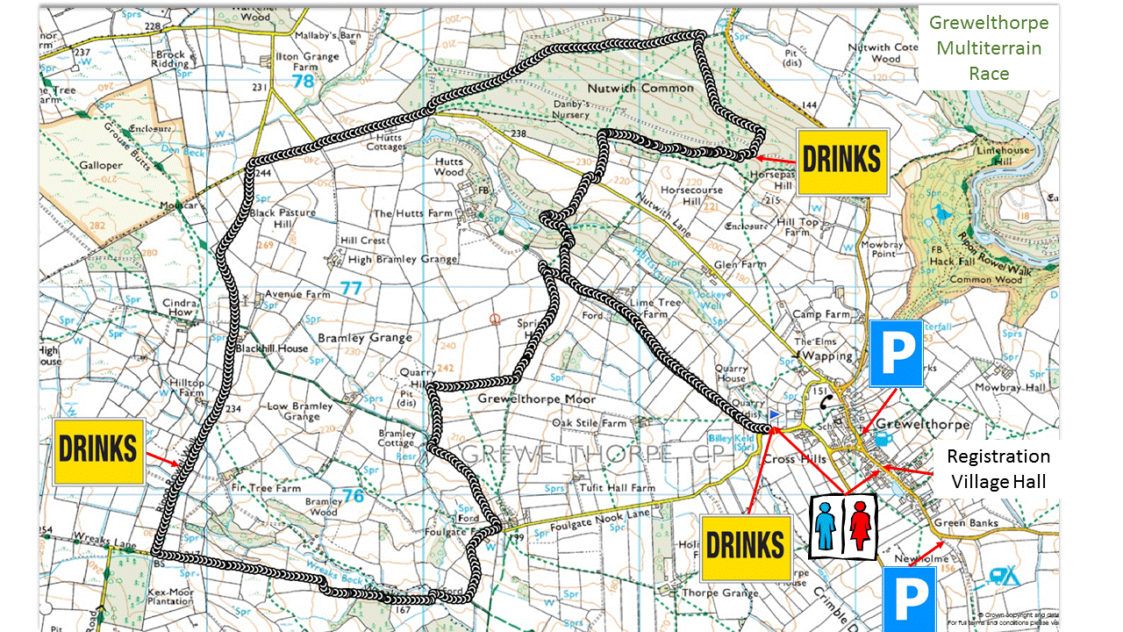

Heading towards the 7km point
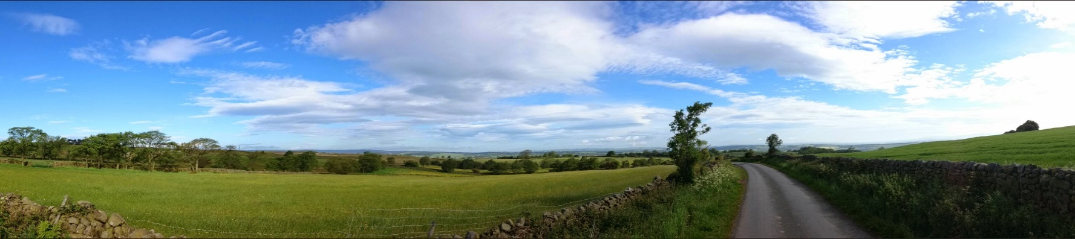

Swinton Woods 7.9 – 10.8km

Refreshments
...will be available in the Village Hall pre- and post-race. Each competitor is entitled to a free tea or coffee and soup on presentation of your race number. There will be free flapjack and bananas at the finish for all runners.

Route
The route is a clockwise loop starting at the bottom of Hutts lane. The first 1.3km up Hutts lane will separate the field before you get to the gate to the first off-road part of the course. The first climb to 238m will take you to a great

view point, before you descend through a field to the gravel track that will take you to Wreaks Lane (also gravel) and the second lowest point of the course (163m), where you can cross Wreaks Beck through the ford or over a narrow footbridge.
Now begins the biggest climb of the course, up to 265m over 3 km (via a water point), where you will be greeted by more cracking views, before a fast decent on tarmac, then a fast and exhilarating decent on gravel tracks through Swinton Woods down to the Masham road. At 146m, this is the lowest point of the course. The last big climb to 229m over 1.8km will take you to Ilton lane (via a water point), and onto a great section through fields and woodland on the Hutts estate. A short but deceptively harsh climb will take you back onto Hutts Lane for a fast finish back in the start field.

There are 5.5km on tar, 4.5km on gravel tracks and the remainder on footpaths through fields and woodland.

As this is a Multiterrain race, there are hazards like loose stones, rocks, roots, streams, mud etc which you need to be alert

to, but I guess that’s why you entered! The race is on open (but not busy) roads.

Results
Results will be available on the race website as soon as they have been compiled.

Rules
The race will be run under UKA rules. Please ensure that you are familiar with these.

For your own safety, and that of other road users, no devices requiring headphones are allowed. This includes but is not limited to MP3 players, phones, iPods and radios. If you are seen violating this rule, you will be disqualified.

First Aid/Medical
Please do not run on the day unless you are well enough to do so.

Your medical requirements will be looked after with a first aid post at the start/finish. First Responder on quad bike, 2 first aiders on course, and one on a 4 wheel drive All- Terrain vehicle.

Please contact the Race Director, Julie Stead-Connor by email on: julie@gmtr.co.uk if you have any questions.



